
Qualicum School District 69
District Parent Advisory Council
AGENDA - General Meeting
Date: Wednesday, October 18th, 2023 (Every month on the 3rd Wednesday)
Time: 6:30PM
Location/Zoom: https://us02web.zoom.us/j/86524034006?pwd=bm9sdnlmSXc1bHJsYjBweVA3UGtPQT09
Meeting ID: 865 2403 4006 Passcode: 365257

Meeting Purpose:
- Engage, empower and support parents/guardians for the success of all learners
- Support, encourage and improve the quality of education and well being of students by being a district voice
- Build relationships, share knowledge and create community
- Public meeting for all parents/guardians with student(s) in SD69
Attendees/Invitees:
- SD69 DPAC Executive Team
- SD69 School PAC Executives/Representatives:
CEAP - Collaborative Educational Alternative PASS
AES - Arrowview Elementary School BES - Bowser Elementary School
EOES - Ecole Oceanside Elementary School EES - Errington Elementary School
FBS - False Bay Elementary School NBES - Nanoose Bay Elementary School
QBES - Qualicum Beach Elementary School SES - Springwood Elementary School
BSS - Ecole Ballenas Secondary School KSS - Kwalikum Secondary School
- SD69 DPAC Committee Members (formed by DPAC President)
- SD69 Representatives: School Year 2023/24
  - Superintendent of Schools: Peter Jory
  - Associate Superintendent of Schools: Gillian Wilson REGRETS
  - Director of Instruction: Rudy Terpstra
  - Trustee(s): Julie Austin, Eve Flynn, Carol Kellogg, Barry Kurland, Elaine Young
  - MATA President: Matt Woods
  - CUPE Local 3570 President: Sherrie Brown- DID NOT ATTEND
  - SD69 Parents/Guardians - Please see “In Attendance” below
  - Guests as requested & required (at the discretion of DPAC President)

In Attendance: Karri Kitazaki, Jessica Threllfall, Angel Delange, Brenda Fischer, Andrea Button, Natalie Morris, Kailee Stafonovic, Julie Birlew, Felicia, Maleah Bajiich, Avrillee Kenney, Brianne Gordon, Jacquie Karkenna, Alison Todsen, Kat Pummell, Jenessa Denton, Amanda Hastings, Sky, Alanna Heeres, Jason Howard, Michael,

2023/2024 DPAC Executive Team:

Karri Kitazaki: President Open/Available Director
Jessica Threlfall: Vice President Open/Available: Director
Open/Available: : Treasurer Open/Available: Director
Open/Available: : Secretary Angel Delange: Past President
Open/Available: Director - FAC/French Advisory Council * to be reviewed 2023/24
Open/Available: District Associate to BCCPAC * to be reviewed 2023/24

AGENDA

- Call to Order: 6:31pm
- Welcome / Traditional Territories Acknowledgment:
We would like to acknowledge that Qualicum School District exists within the territories of the Coast Salish People and within the shared traditional territories of the Qualicum and Snaw-Naw-As (Nanoose) First Nations.
- Introductions & Quorum Declaration: Quorum: 3 voting members
- Approval of Agenda: Angel
- Approval of Previous Minutes: Jessica
    - Peter Jory Update: Correction in numbers of the anti-SOGI group. It started as 50 but was more like 100 people by the time they moved to the cenotaph.
    - Open Discussion Addition: Ray (AES) asked about the process for sharing of DPAC/PAC Bank statements and Karri (DPAC) will look into it
    - Post meeting addition to the minutes to include: Ray Woroniak’s suggestion to view the COW/Policy meeting to include reference to “Policy 301: Living Wage.
- SD69 Updates: Report, update, questions
  - Superintendent/Associate Superintendent of Schools
Dr. Peter Jory / Superintendent Update:
- We’re moving away from SD69 and embracing a more local name and falling in line with most SD’s in BC. We are replacing SD69 with Qualicum School District. More and more school districts are dropping the number part of their name.
- Our new logo was created by Jessie Recalma, a local Indigenous person who is part of the Qualicum First Nation, is an employee of the Qualicum School District and a grad from KSS.
- It was felt by many that a change in our logo was needed and approved by the board and mini focus groups.
- Continued great start up, high positivity, and schools have been reporting best start up ever.
- Our overall numbers increased by approximately 40 students, the CEAP and PASS programs are shrinking back to pre-covid numbers.
- We recognize that both of these programs play a valuable place in our community, but we are happy to see more kids returning into bricks and mortar classes.
- Due to changes in Operations, the grounds crews were able groom the school grounds over this summer.
- The bus system upgrades have proven to be successful. We were able to start online registration for the 2023/2024 school year in the spring, allowing us to confirm 80-90% of riders/families knew well before the start of the school year if they received a spot on the bus.
- PJ asked if there were any parents attending the meeting and could speak to this - we had a few parents speak up and consensus was the new program is much easier to use. Parents could select multiple routes and passes for multiple kids, could pay their fees and are able to reuse the old pass.
- Integration of routing software to become more efficient and create less wait times for kids is being looked into. We are currently using “on paper routes” and we need to look into routing software to help create the best and most efficient routes to help reduce the time kids are on buses.
  - Director of Instruction
Rudy Terpstra / Director of Instruction Update:
- Thanked DPAC for their letter they received last week (asking for the SD to show support for human rights).
- Attended a SOGI summit last week and it was excellent.
- We are in full swing, teachers are planning lots of learning events, using learning strategies to hit the proficient and target learning updates that we can expect coming home in November.
- Highlight Learning Grants - are available from our SD and cover a wide focus of fields and it’s open to teachers. Teachers can access these grants for a large variety of activities, speakers, events.
- It’s important to know that Pro-D days are important for teachers and support staff because it allows them opportunities to continue learning.
- The December 01 Pro-d day has a keynote speaker coming to discuss Indigenous Learning.
- Parents are encouraged to ask their teachers and/or admins what their pro-d days are focussing on and what the goal of the day is.
  - Trustee
Trustee Update / Elaine Young:
- Paraphrased what Rudy said about the importance of professional development days, it is incredibly important because education is constantly changing.
- BCSTA - BC School Trustees Association serves to support Trustees and provides professional development opportunities. Carol Kellogg, Julie Austin and Elaine attended a Vancouver Island Trustee Association and it had lots of great guest speakers.
- Busy week with the Committee of the Whole/COW meetings took place this week. Thanks to DPAC for encouraging parents to attend the meetings because there is a lot of great information.
- Appreciated the many letters of support that they have received supporting SOGI.
- Next week is the monthly public meeting, please talk to the Chair of each COW meeting, ask questions, and become involved.
- Next Coffee with Trustees is happening on Wednesday November 1st, beginning around 2:30pm at Arrowview Elementary School.
- Pleased with the parent turnout at the last Ballenas Secondary School PAC meeting.
- Attended False Bay recently and was pleased with what they are doing.
  - MATA
MATA Update / Matt Woods
- Echos Elaine and leadership that although we may have differences of opinions, the working relations are always respectful.
- Thanks to DPAC for supporting teachers and learning.
- Many years ago, year end school dismissal was usually typically early June. Teachers negotiated to have extra professional development days throughout the year so the pro-d days do not reduce the required number of educational days in the school year.
  - CUPE - REGRETS
- Reports: Report, update, discuss, recommendations, questions
  - President/Vice President: (Karri/Jessica)
    - Qualicum SD Parent Information Night: Oct 26th - 6-8pm @ BSS
- Encourages all PACs to share this information poster, DPAC has forwarded it to all school pac emails.
- This event was first held in the spring and although there wasn’t a lot of time given, it was well attended and parents were engaged.
- While the content is for mature audiences, the SD will not deny kids access to the event.
- You’re learning real up to date heavy content.
    - BCCPAC Leadership Manual: https://bccpac.bc.ca/index.php/resources/16-dpac-pac/523-leadership-manual
- The BCCPAC is an organization run by volunteers who work very hard to create easily accessed information to help support local PACs and DPACs.
- While this group is a fantastic resource, it is important to realize that a lot of their links and brochures are many years old, and may not reflect the current learning climate.
    - BCCPAC DPAC Summit: https://bccpac.bc.ca/index.php/events/dpac-summit
- DPAC can send one representative for sure, and possibly a second person is space if available. The event is paid for, and the cost of the ferry and gas (paid at a per km rate) can be expensed back to DPAC. * Either the hotel is also covered by BCCPAC but if not, DPAC would cover that expense.
  - Treasurer Update: (Brenda)
- Treasurer Update / Brenda:
- Please see the account details below.
- Due to the covid years, and not using the gaming grant funds, we had a surplus of unused funds. We were bound to discharge all funds by June 2023 or repay unused funds back to the BC Gov’t. Please see what we were able to spend those extra funds on in the notes below.
    - October 17, 2023 DPAC Account Summary
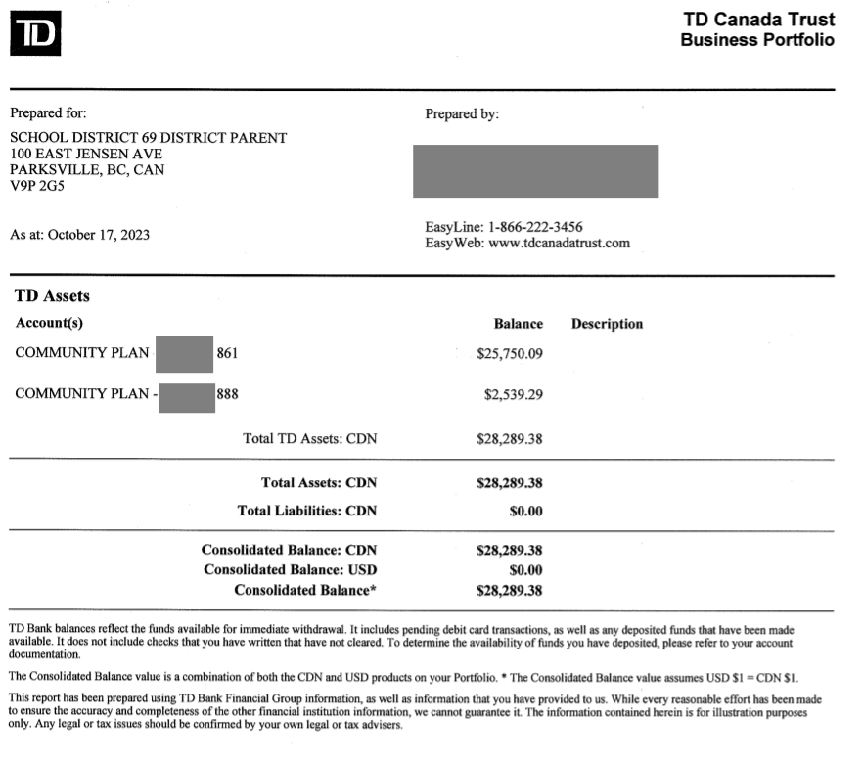
    - 2022/23 Gaming Grant - Summary Snapshot (extra “COVID carry over money” utilized)
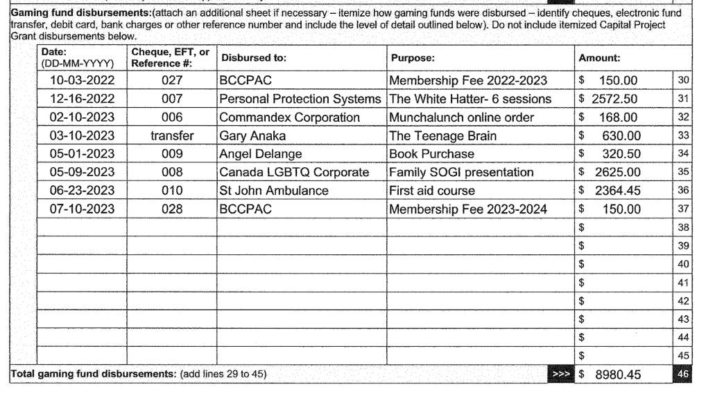
- DPAC Treasurer emails bank statements monthly to DPAC Email

  - Committees: Ad-hoc (specific task/objective, dissolved after completion)
    - Accessible Bikes - (Jessica)
- The organization that was loaning the SD their bike is having their bike refurbished next week and will likely be willing to sell it to us. They are meeting next week and once they decide, they will contact DPAC and then we can discuss this as an option further.
- Angel added: We do not need to vote on this b/c it was voted on in June 2023. Spending up to $10K of DPAC funds, along with the $9,500 in grant money we have received was already approved.
  - Committees: Standing (specific task/objective, ongoing & continued existence)
    - FAC - French Advisory Committee: Next Meeting: Nov 27(Natalie/TBD)
- As per Rudy, DPAC does not necessarily need to have a representative attend as long as the SD has one from BSS and EOES in attendance.
- Amanda Wagner is the BSS rep
- CPF/Canadian Parents for French President Andree Rupta is invited
- EOES needs a representative to attend
    - School PAC Updates/Roundtable: (Highlights Presented by School PAC Rep)
      - CEAP - Collaborative Educational Alternative
CEAP Update as presented by Maleah
- Their PAC has a full executive this year
- Primary students attend school early in the week for 2 days
- Intermediate attends Thurs and/or Fridays
- Creating a new website for their PAC
      - PASS - DID NOT ATTEND
      - AES - Arrowview Elementary School - DID NOT ATTEND
      - BES - Bowser Elementary School - DID NOT ATTEND
      - EOES - Ecole Oceanside Elementary School
EOES Update as presented by Avrillee
- Bagel cafe is open with PAC voting unanimously to cover the cost of offering free bagels. The admin will contribute $2K.
- Hot lunch is starting soon on Thursdays and there is a chance to offer it on Mondays as well.
Added by Angel
- We held our first PAC meeting earlier in October and I created a new addition to our agenda called, “Human Rights Advocacy” and I included links for parents to consider viewing to help better understand what is actually happening in our schools. That all of our families and children must know that they are safe and feel included within our school community. If parents want to challenge the SOGI curriculum, PAC meetings are not the place. Contacting your MLA and BC Government is where those concerns need to go. If anyone wants to see how I prepared it, I am willing to share.
      - EES - Errington Elementary School
EES Update / as presented by Erin
- Her first year on PAC, lots of new parents stepped into roles on PAC.
- Fundraisers like movie nights have been successful.
- They would really like to be able to offer parent education courses like The White Hatter.
      - FBS - False Bay Elementary School - DID NOT ATTEND
      - NBES - Nanoose Bay Elementary School - DID NOT ATTEND
      - QBES - Qualicum Beach Elementary School
QBES Update / as presented by Jason
- Growing smiles poinsettia fundraiser is happening.
- Teacher conferences are this week.
- They are interested in updating their Constitution.
- They would love to see a bike shelter built.
- Interested in learning more about “Walking School Bus and some suggestions were made, to review ICBC’s website for their “Safe routes to schools” tab
      - SES - Springwood Elementary School
SES Update / as presented by Julie
- They were pleased to offer the White Hatter to their grades 4-7 earlier this month.
- Parent conferences were happening this week.
- Fundraisers like the soup one was a nice change, and the support for the book fair was much appreciated by their librarian.
- Hot lunch program is in full swing and is going really well.
- Asking what other schools are receiving as far as newsletters from school/teachers and does your PAC offer one? If so, what does it include?
      - BSS - Ecole Ballenas Secondary School
BSS Update / as presented by Karri
- Really pleased with the latest PAC turn out, approximately 20 people were in attendance.
- New Executive has 8 people on it, the PAC Executive has grown so much in the last few years with more and more parent involvement. When she first started there were times that only a couple of people would attend, and you cannot get anything done with a couple of people.
- There are currently 11 sports teams running and about half are run by parents and supported by Community volunteers coaching teams.
- Karri is hopeful that all parents will attend this SD information night because it is full of valuable information.
      - KSS - Kwalikum Secondary School
KSS Update / as presented by Kat
- Their Leadership Team beat their goal of raising $10K and raised $10,500 for the Tour de Rock.
- They held a dance and raised over $700 that went to the Tour de Rock.
- KSS, BSS, and PASS are hoping to access infrastructure food money and with those funds, KSS is hoping to have a full industrial kitchen onsite for the fall of 2024.
- They would like to see an outdoor basketball court put in, but an outdoor classroom at KSS is a priority.
- Unfinished Business: Items carried forward from last meeting
  - School PAC Constitution Review: (Angel & Karri)
- Angel has offered to help any school PAC rewrite their constitution
  - DPAC Constitution Review (Karri)
- Karri reminded people that a lot of our constitutions are outdated, and most definitely will not have updates to account for things like pandemics.
- Even the current DPAC constitution that was reviewed a couple of years ago could use a fresh look.
- New Business: Items requiring a discussion, recommendation, decision
  - 2023/24 DPAC Elections (Karri)
- Nominations were received for the following and all four have been acclaimed into these roles:
Treasurer: Brenda Fischer
Secretary: Angel Delange
Directors: Michale Kilburn, Amanda Hastings and Andrea Button
*One Director position remained unfilled during the meeting and Karri suggested if anyone was interested in filling this void to please email DPAC. Since the meeting, Andrea Button has emailed and put her name forward for this position.
  - Coffee with DPAC - October 25th at 10:30am upstairs at Parksville QF.
Karri:
- Any DPAC or PAC representative is welcome to attend. It’s a great way to get to know other PACs and chat about what is working and not working for them.
- Previous years bank statements will be available for viewing.
- Open Discussion: Questions, concerns or comments
Is the DPAC zoom meeting and password the same? YES
Do we only need one rep for FAC? We only need to have a rep from BSS and EOES and if not, then a rep from DPAC would be asked to attend.
We will check and see if other DPACs have BCCPAC reps on their Executives.
- Next Meeting: November 15, 2023 at 6:30 via Zoom
- Motion to Adjourn: 8:10pm

